**ENGINEERING JOURNAL TEMPLATE**

# Date

09-14th Feb

# Solutions

*Software:*

I created an mqtt handler that will connect to the broker with my personal credentials

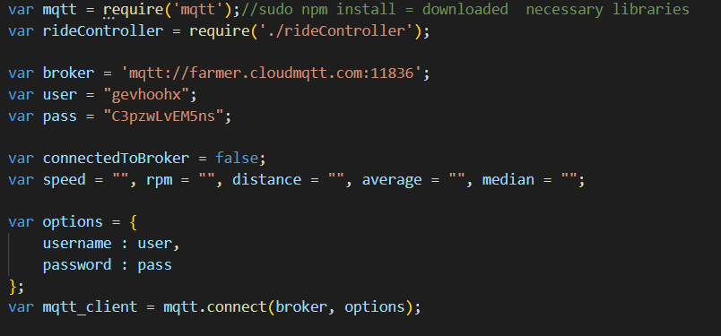

I then created the clients to be connected for the topics coming from mqtt

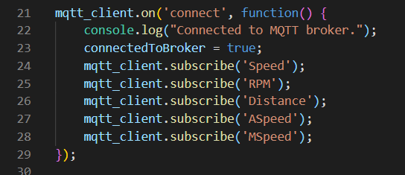

I am checking to see if the topics are empty/ equal to 0, if they are equal to 0, then just send the speed and rpm, then if the remaining topics are not equal to nothing , I send all the topics to rideController.js

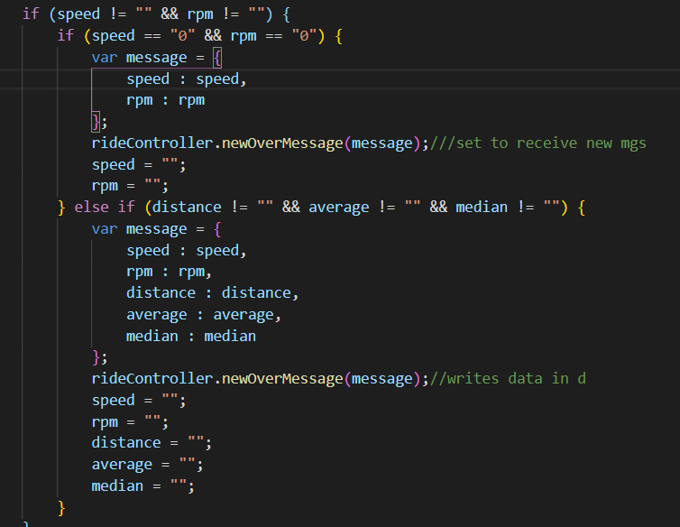

The export statement is used when creating JavaScript modules to export functions, objects, or primitive values from the module so they can be used by other programs.

So a ride function is being used to write and save the data that was send from mqttHandler.js. I believe this is then pushing to the db

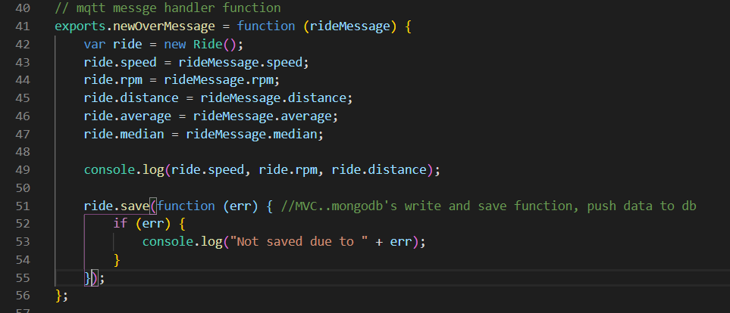

**TASKS**

I also want to start thinking about how I want this webpage will look

I was thinking to do it by date stamps – as you will likely only go for one ride in any given day

For connecting to the mqtt client I used <https://www.hivemq.com/blog/mqtt-client-library-encyclopedia-paho-js/> to help me